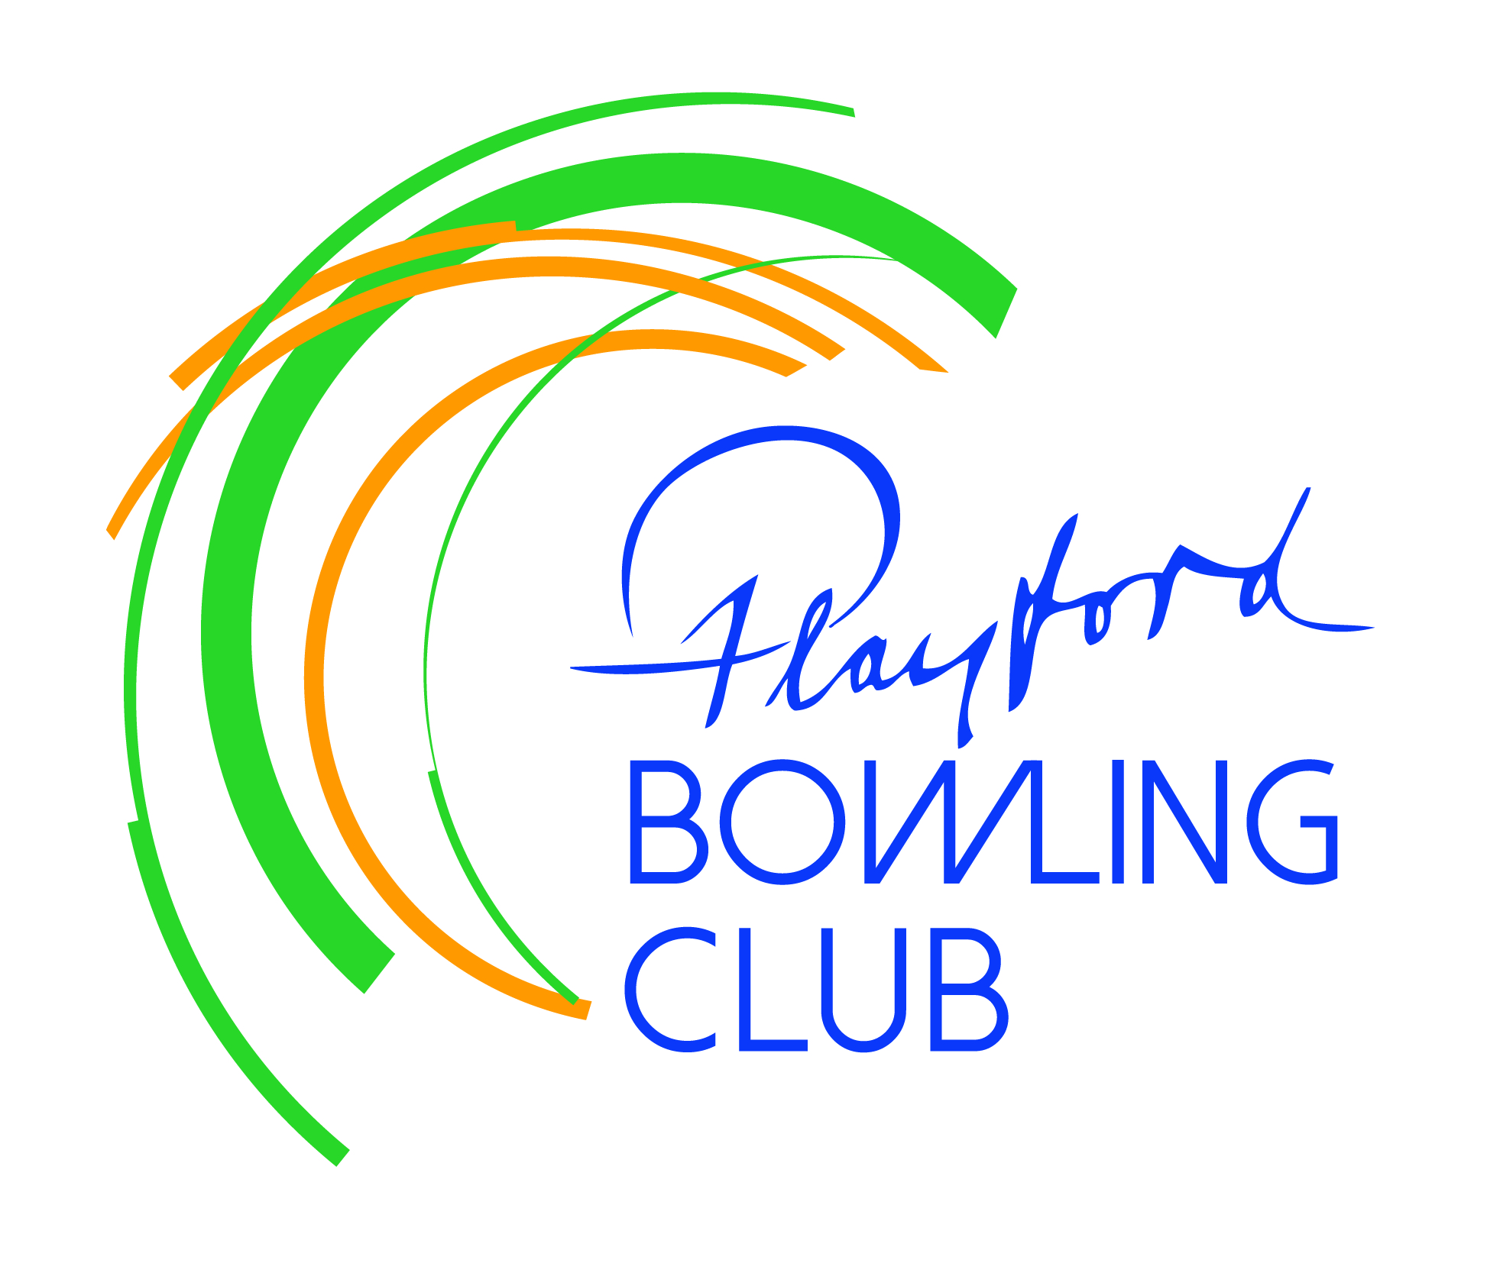 Playford Bowling Club Inc.

16 Goodman Rd Elizabeth SA

Phone 8255 1895

|  |
| --- |
| **MEMBERSHIP RENEWAL 2024/25** |

**Please lodge when you pay your membership fees**

**Membership type** **Full** $225.00 🞎

**New Full (New Bowler)** $225.00 🞎

**Associate**  $100.00 🞎

**Junior** $ 80.00 🞎

**Social** $ 40.00 🞎

**Please see over page for details of membership categories**

**Last name**....................................................................................................................................

**First name**...................................................................................................................................

**Preferred name** (*eg. Bill instead of William*).............................................................................

**Residential Address**...................................................................................................................

.....................................................................................................Postcode..................................

**Postal Address** (*if different*)........................................................................................................

.....................................................................................................Postcode...................................

**Home phone**..............................................**Mobile number**........................................................

**Email Address**.............................................................................................................................

**⬜ I have read and agree to abide by the Code of Conduct Policy of the Playford Bowling Club**

**⬜ I agree to my contact details being made available to the Club’s selection panel and our relevant State authorities (essential for pennant bowlers)**

**Signature**.......................................................................................**Date**......................................

**EMERGENCY CONTACT DETAILS**

**Person to be contacted**.........................................................................................................

**Contact phone number/s**...........................................................................................

**MEMBERSHIP CATEGORIES**

**Full Member –** Applies to renewing/transferring members

If you are new to bowling you get a free shirt

Voting rights, eligible to stand for the Board

Access to greens whenever they are available for use.

**Associate Member –** Can play a maximum of 3 pennant games.

No voting rights and unable to stand for club positions

Access to greens whenever they are available for use

**Junior Member –** students

For pennant bowlers – essentially just the capitation fee

If you are new to bowling you get a free shirt

No voting rights and unable to stand for club positions

Access to greens whenever they are available for use.

**Social Member**

If you are a partner of Full or Associate Member – fee is $20

No voting rights and unable to stand for club positions

No access to greens